**CAR DEKHO USER GUIDE FOR**

**‘USED CAR PRICE PREDICTION’**

**Links -** Local URL: <http://localhost:8501>

Network URL: <http://192.168.1.5:8501>

**Step 1:** Click the any one link among the local URL or network URL to enter into the Streamlit page. You can find an image below which is the outlook of the Streamlit page.

**Step 2:** Enter the Car Specification details on the left side of the Streamlit Page.

**Step 3:** You will find 15 Specification of the Cars fill which is necessary for you to predict the Price.

**Step 4:** Fill the details and click on the Predict Price Button to view the Predicted Car Price.

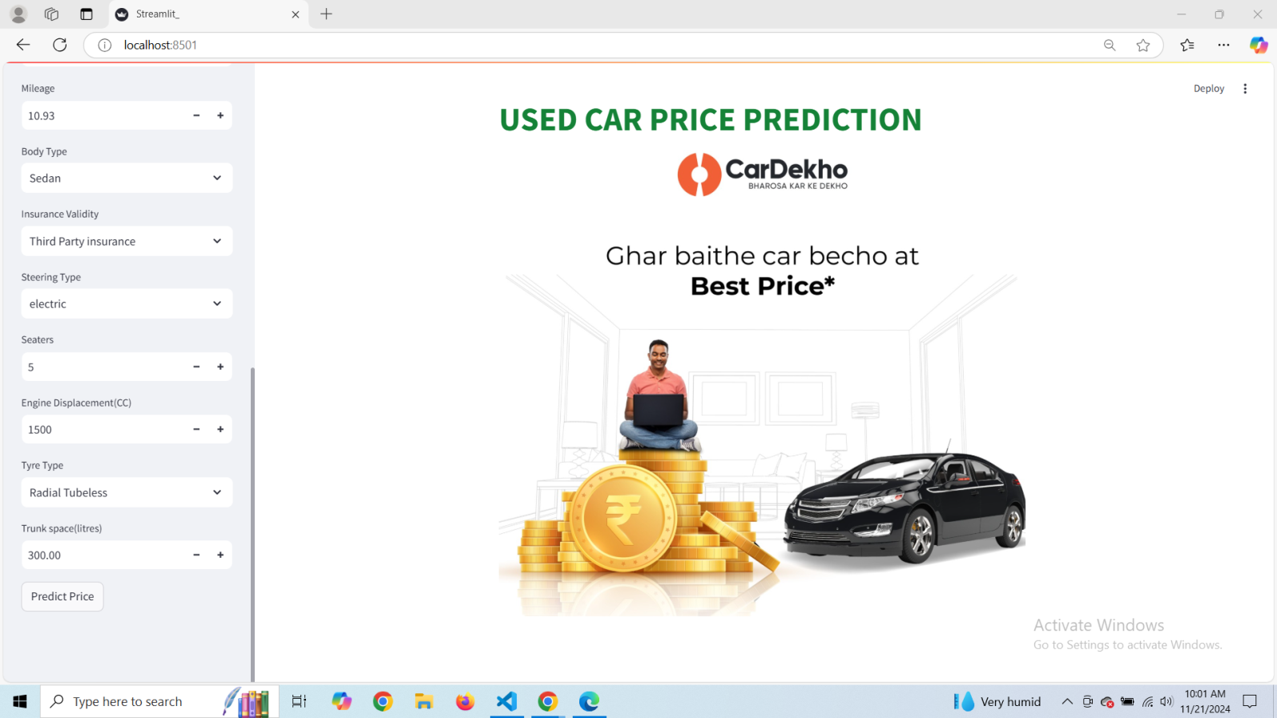

Finally you can view predicted price for the Entered Car Details in the green box on the main page below.

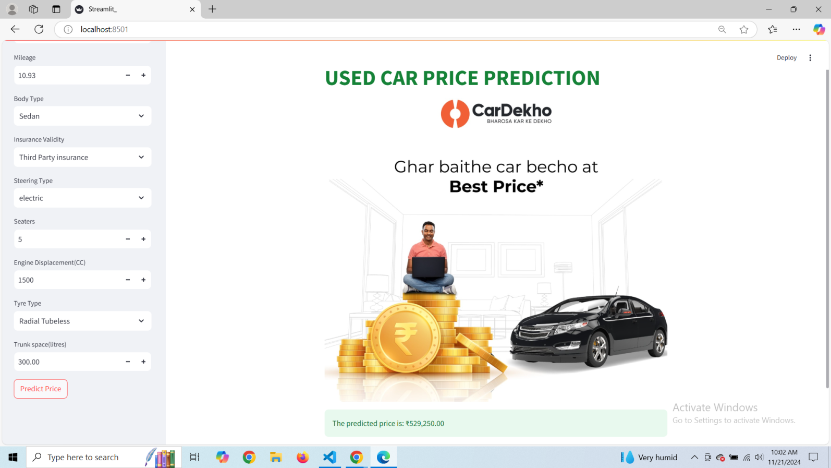 Prepared by – Mirthu Baashini B